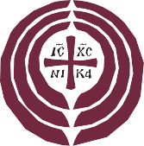
ARCHANGEL MICHAEL GREEK ORTHODOX CHURCH

100 Fairway Drive, Port Washington, NY 11050
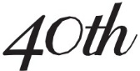
Tel.: 516.944.3180 • Fax: 516.944.3185 • Email: journal@archangelmichaelchurch.org
.
[J
JOURNAL CONTRACT

The undersigned agrees to support the 40th Anniversary Journal by contributing $ for a page. Deadline for Submission of Ads: August 15, 2021

NAME: COMPANY: ADDRESS: CITY: STATE: ZIP: PHONE: EMAIL: DATE: SIGNATURE: SOLICITED BY:
□GOLD: $1,000
□SILVER: $500
□WHITE: $200
□HALF WHITE: $125
Circle One: CASH
CHECK
CREDIT CARD

Use my previous Ad
Use attached / e-mailed artwork
Create artwork using the enclosed/ emailed information

CHECK: Make checks payable to The Archangel Michael Church and mail to:
The Archangel Michael Church 100 Fairway Drive, Port Washington, NY 11050, Attn: Journal Committee

E-MAIL: E-mail your request/order form to journal@archangelmichaelchurch .org or fax to 516.944.3185.
You can also access the form online at https://archangelmichaelchurch.org/journal
CREDIT CARD: Charge D Visa D Mastercard D American Express
Name on your card: Credit Card number: Expiration Date: Code:

